**Name: UPAS NATH**

**Roll No: 47**

**Batch: MCA-B**

**Date:21/03/2022**

**NETWORKING & SYSTEM ADMINISTRATION LAB**

**Experiment No.: 1**

**Aim**

Install the latest version of Ubuntu on an Oracle VM VirtualBox.

**Procedure**

**Step 1-**To start with, we will download VirtualBox and install it.

**Step 2** − Once the option is selected, click on “Next”.

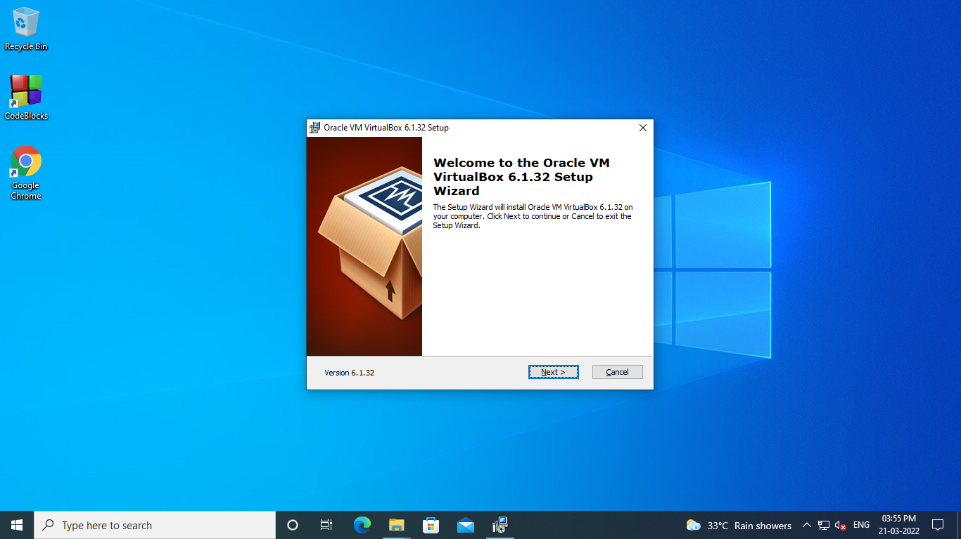

**Step 3** − You have the option asking where to install the application. We can leave it as default and click on “Next”.

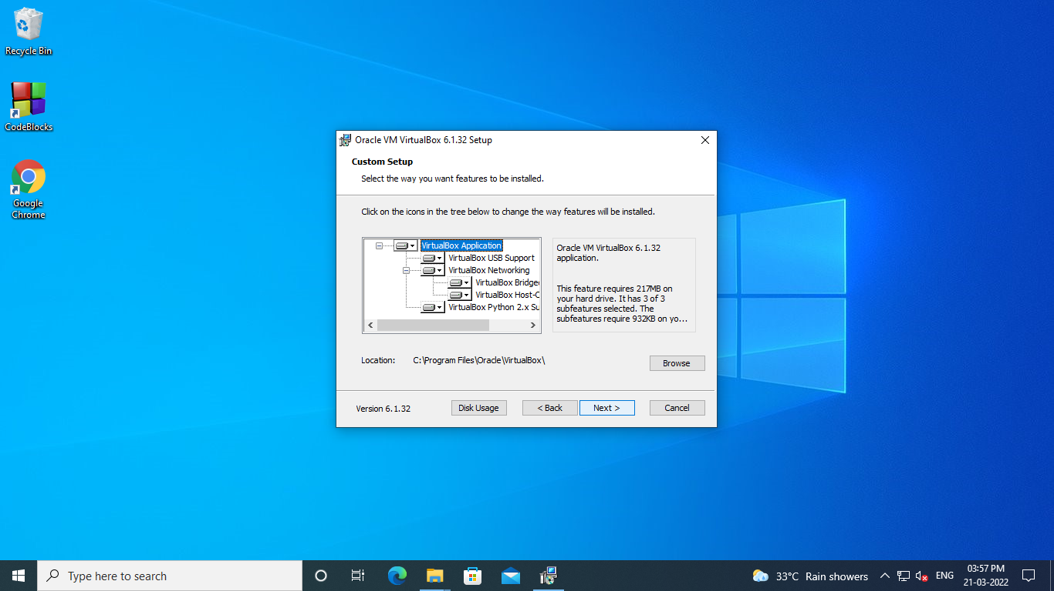

**Step 4** − Once the options are selected as shown in the following screenshot, click on Next.

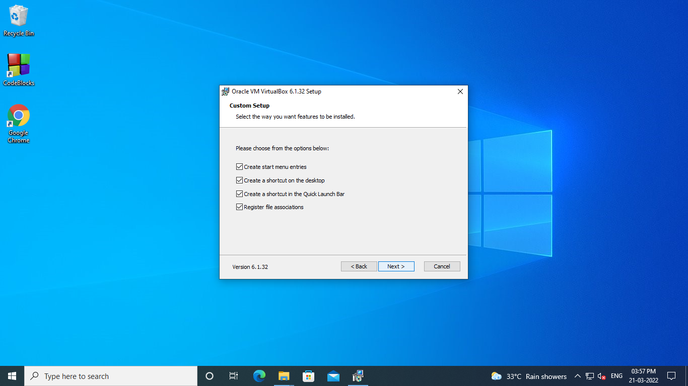

**Step 5** − A dialog box will come up asking whether to proceed with the installation. Click “Yes”.

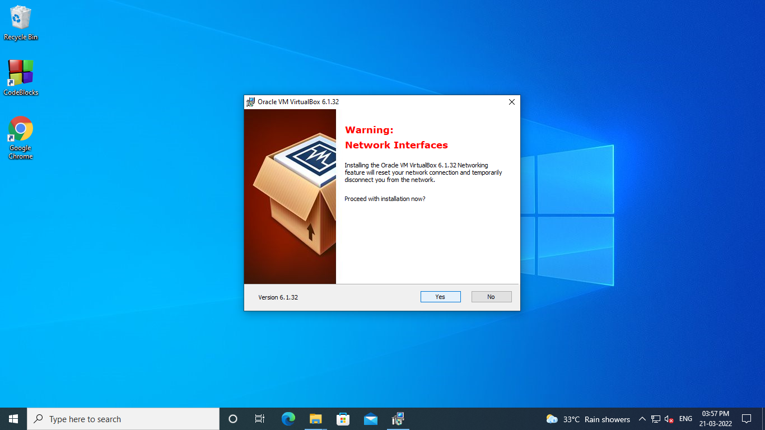

**Step 6** − In the next step, click on “Install”.

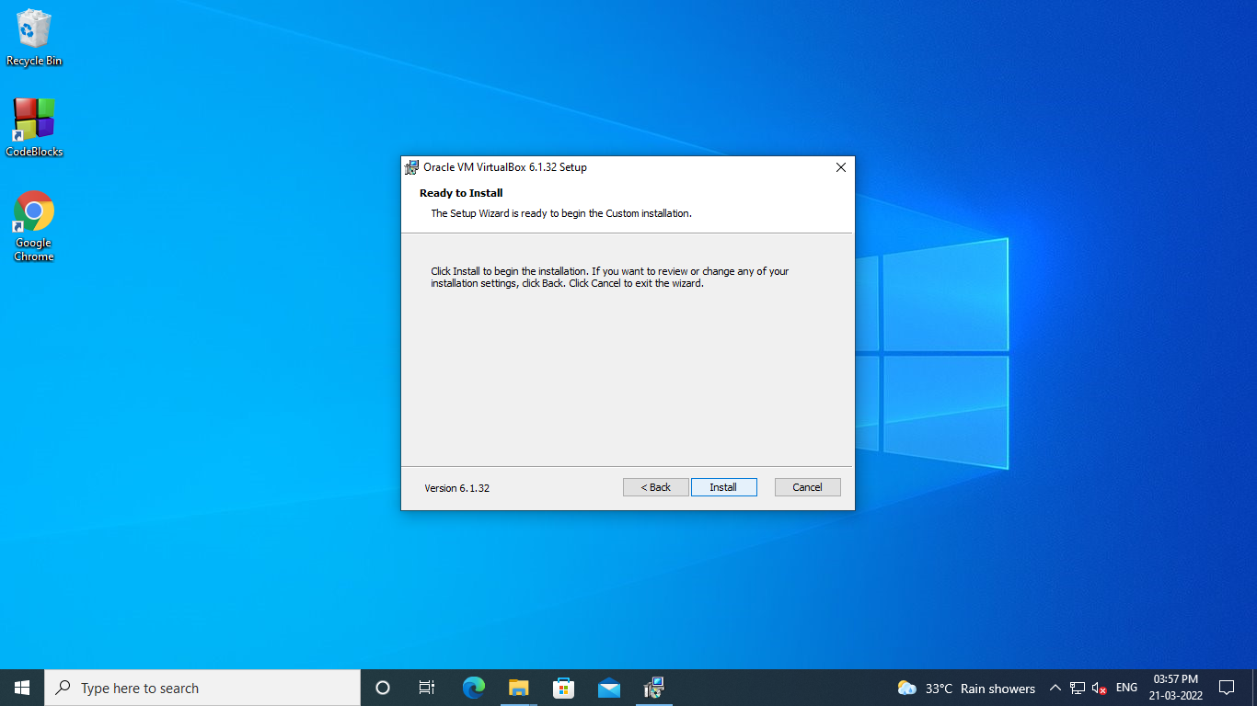

**Step 7** − Tick the start VirtualBox check box and click on “Finish”.

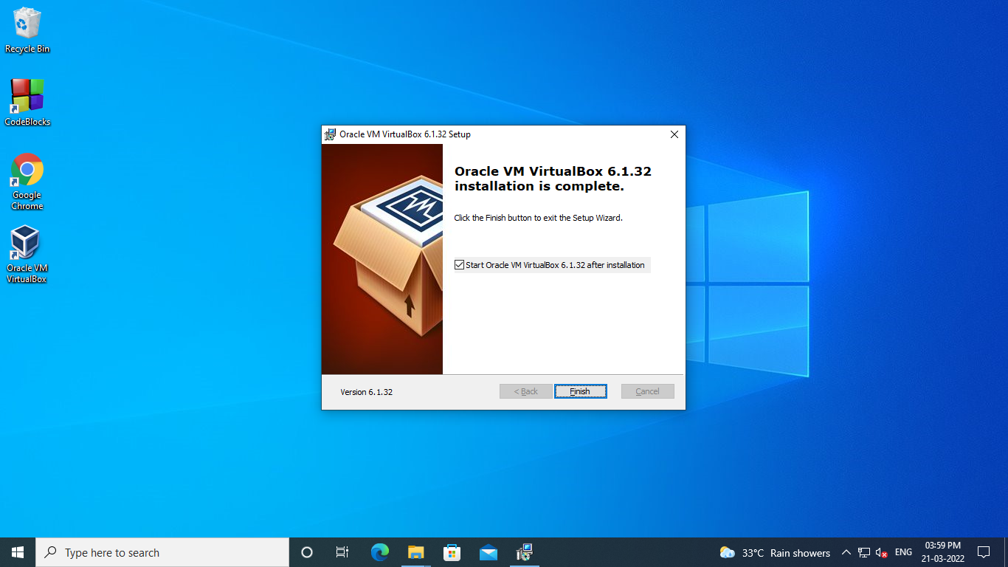

**Step 8** − VirtualBox application will now open as shown in the following screenshot. Now, we are ready to install the virtual machines.

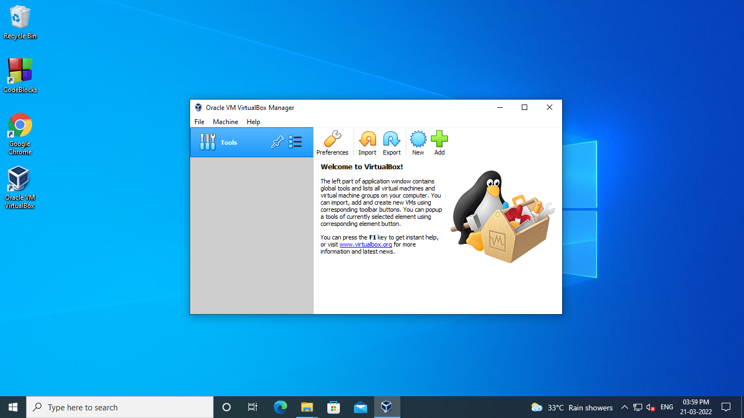

## Creating a VM with VirtualBox

To create a virtual machine with Oracle VirtualBox, we should follow the steps given below.

**Step 1** − To begin with, click on the “Oracle VM VirtualBox” icon on the desktop as shown in the screenshot below.

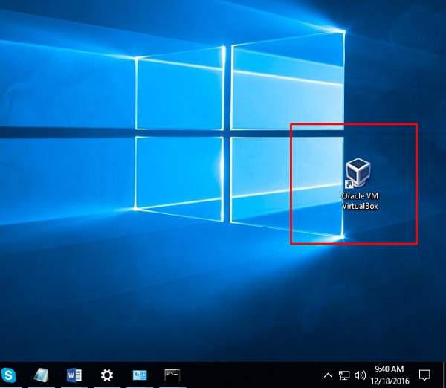

**Step 2** − The next step is to click on “New” button, which is in the top left hand side of the screen.



**Step 3** − A table will pop-up requesting you the parameters for the virtual machine. These will be −

* **Name** − We have to put a friendly name for this Virtual Machine.
* **Type** − Enter the OS that is going to be installed on it.
* **Version** − Enter the specific version for that OS, which we have selected earlier.

Once all the above parameters are filled, click on “Next”.

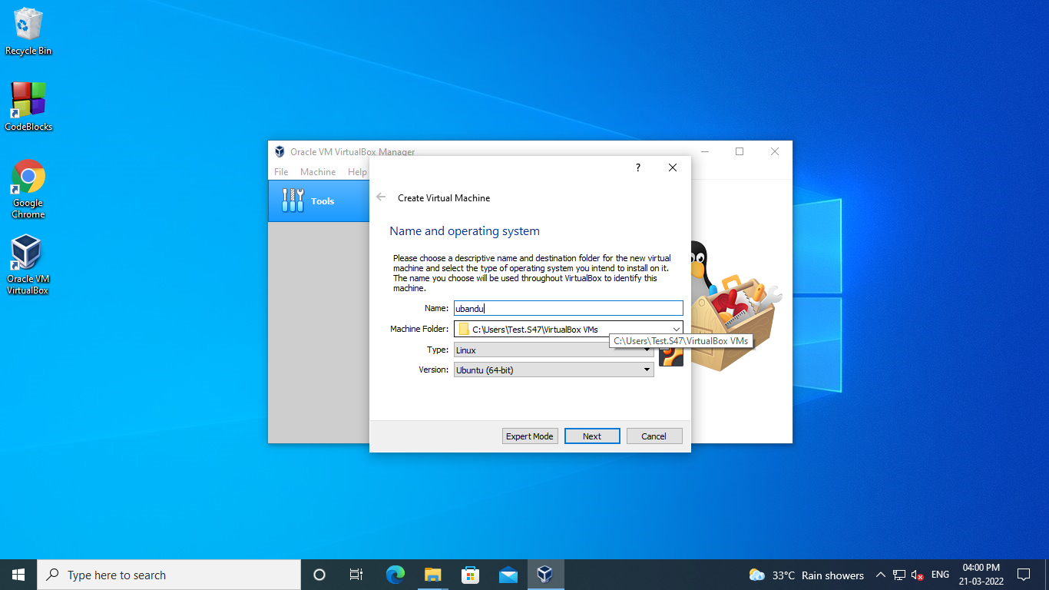

**Step 4** − Select the amount of memory that you need to allocate in this VM → Click on “Next”.

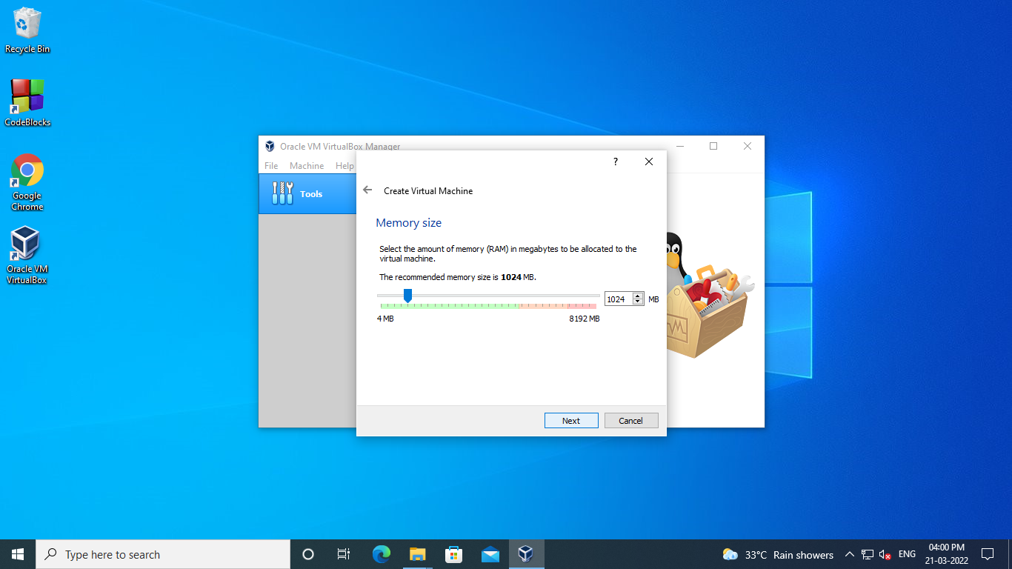

**Step 5** − Check one of the three options for the HDD and click on “Create”.

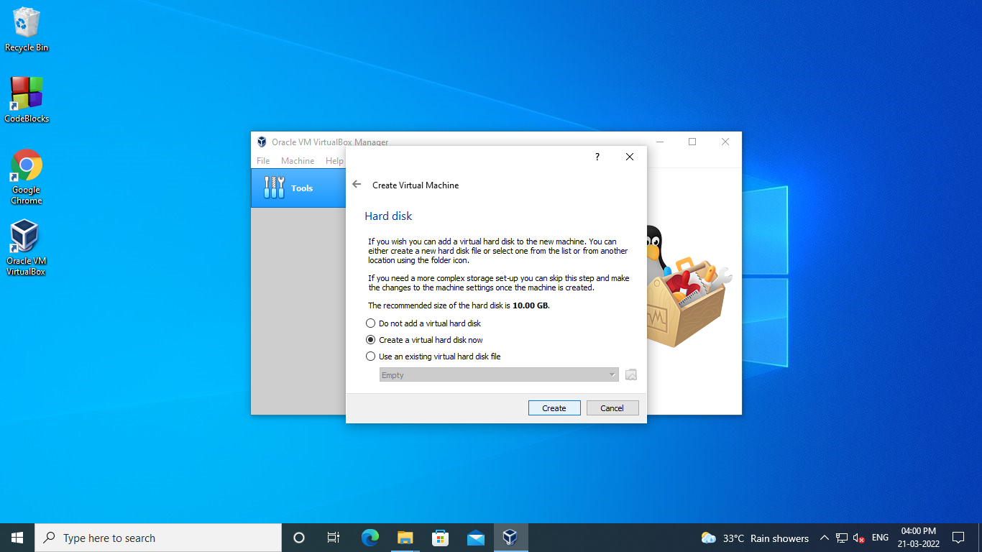

**Step 6** − Select a file extension for your virtual HDD (It is recommended to use a common file extension that most of the hypervisors use like VHD) → click on “Next”.

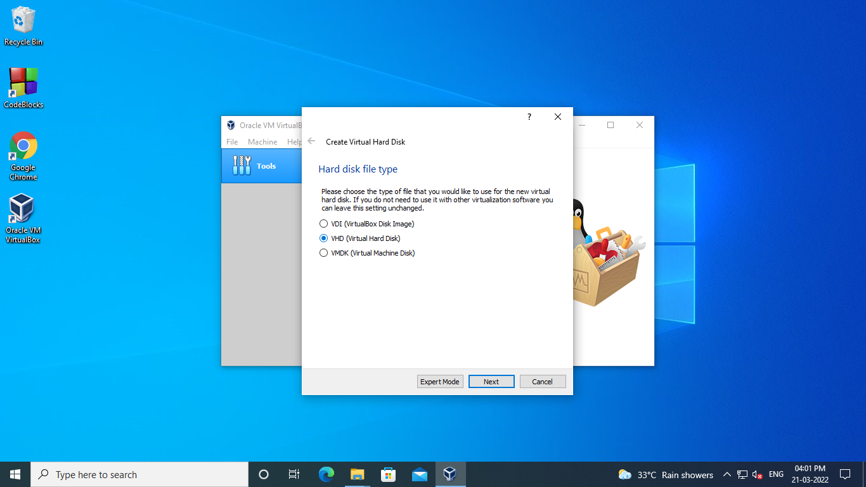

**Step 7** − Choose whether you want the Virtual HDD as dynamic or fixed. This is based on your needs → Click on “Next”.

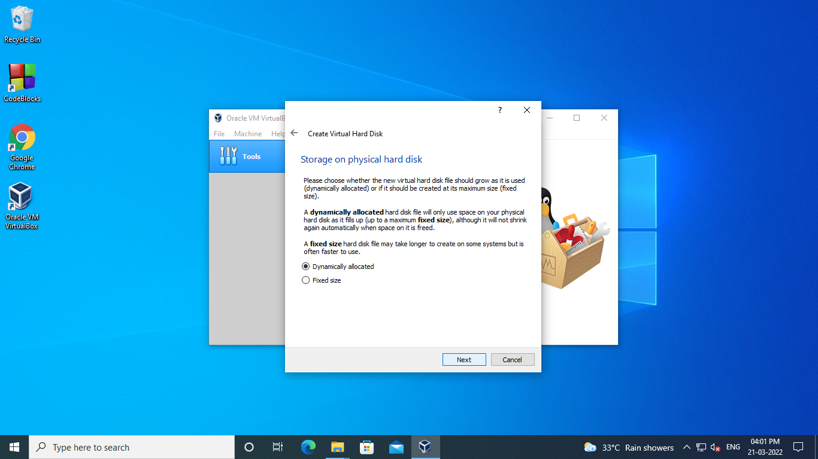

**Step 8** − Put a name for your virtual HDD file and select the disk size for your VM → Click on “Create”

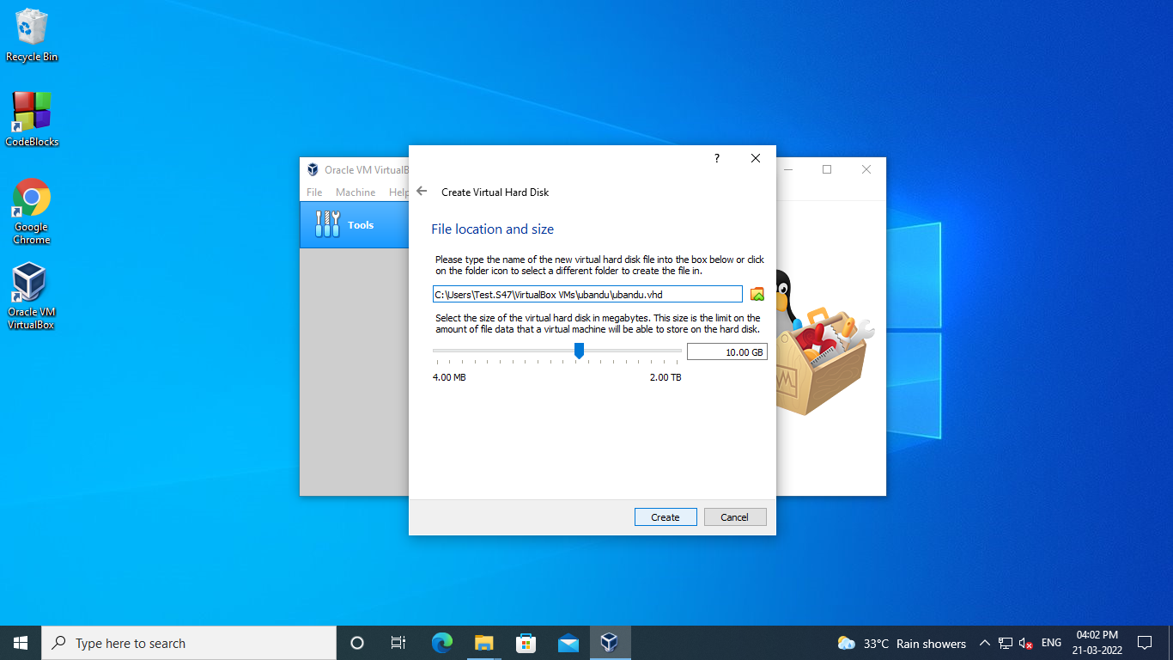

**The virtual machine created will be as shown in the screenshot below.**

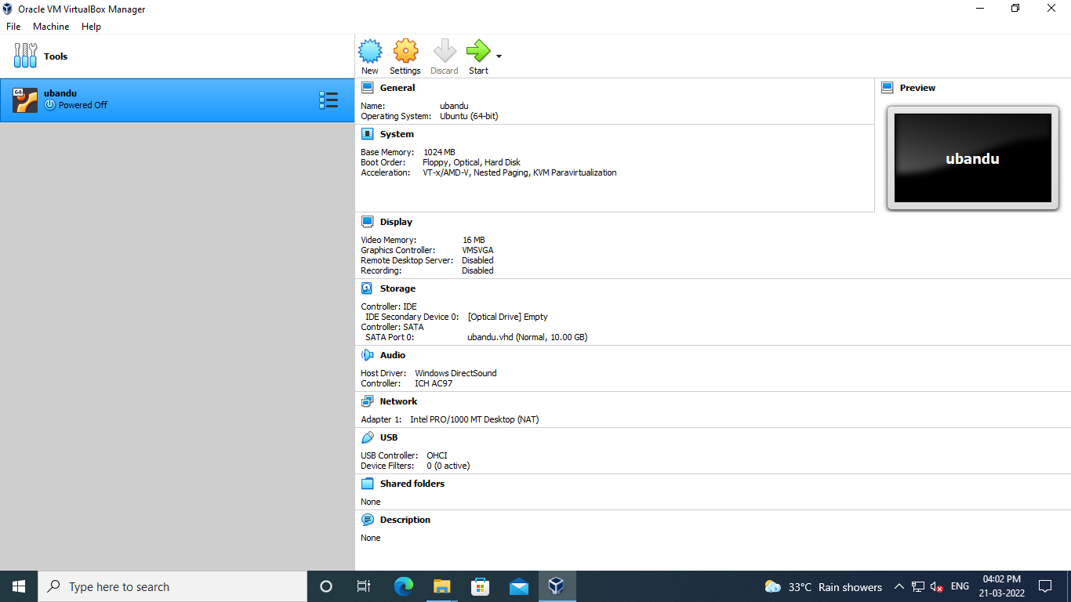

**Step 9-Virtual Machine Storage Settings**

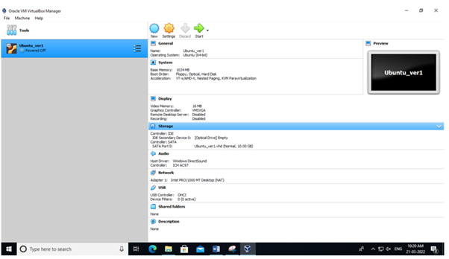

**Step-10** :select **Empty** below the IDE Controller.

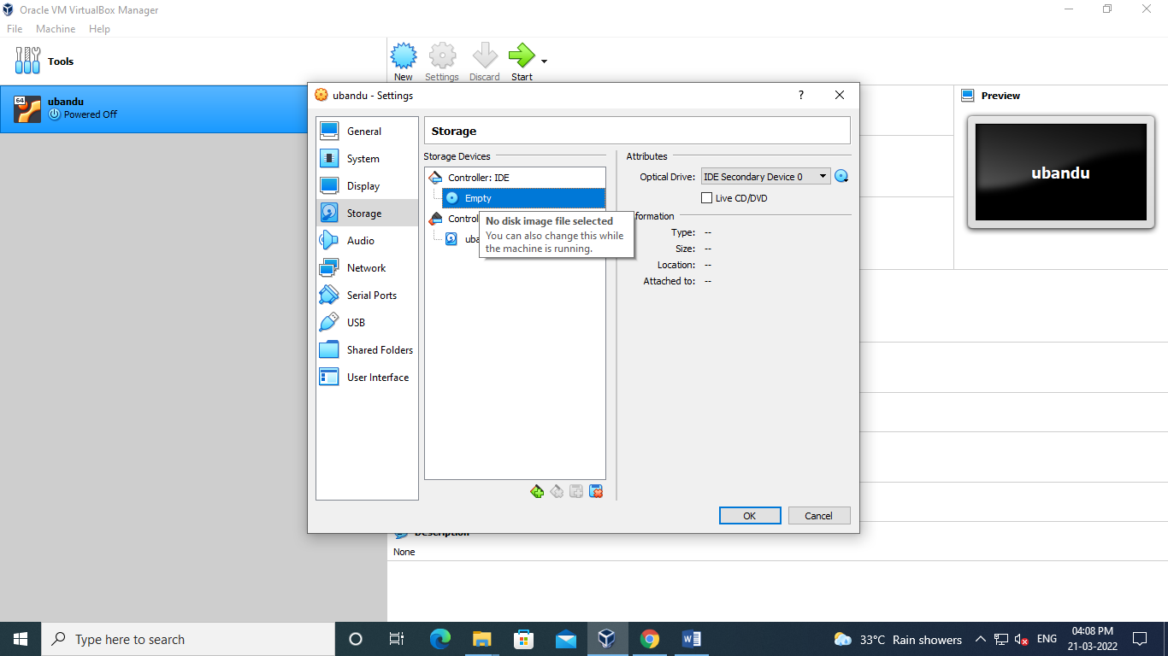

Click the CD/DVD icon next to the **CD/DVD Drive** drop-down list and select the location of the installation media, as follows:

* To connect the virtual CD/DVD drive to the host's physical CD/DVD drive, select **Host Drive *<drive‑name>***.

To insert an ISO image in the virtual CD/DVD drive, select **Choose a virtual CD/DVD disk file** and browse for the ISO image.

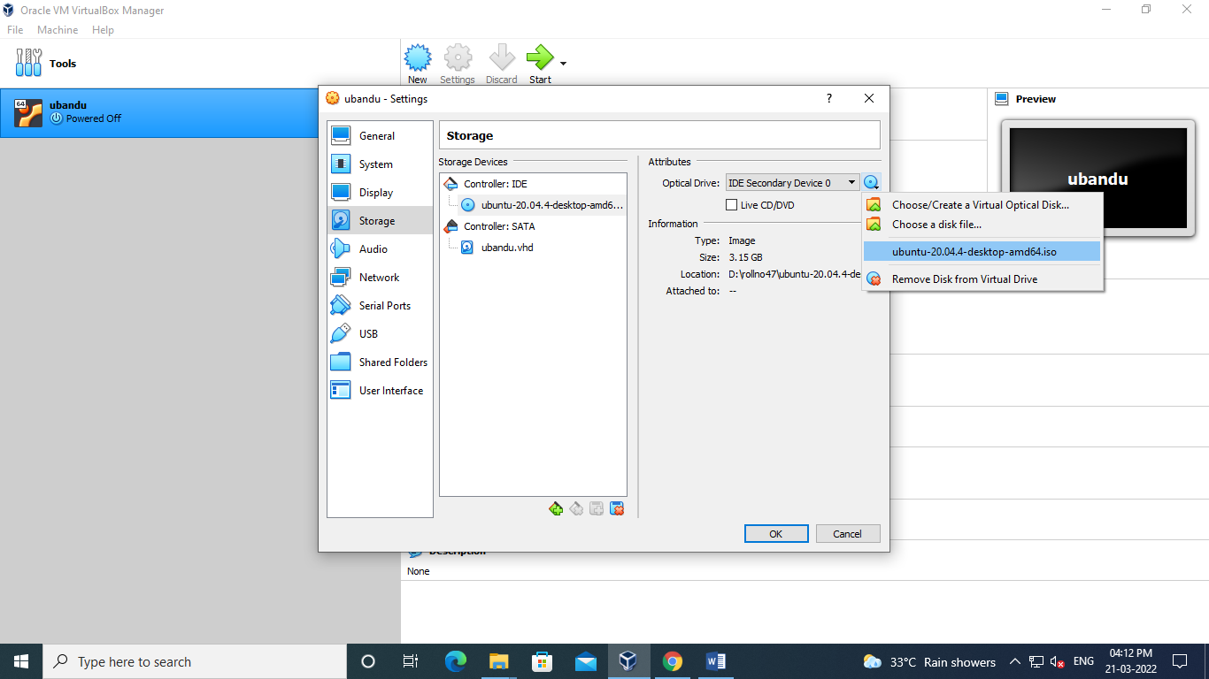

\***Click OK to apply the storage settings**

**\*In Oracle VM VirtualBox Manager, select the virtual machine and click the Start button in the toolbar.**

**Step** 11-**An Installation Program in a Running Virtual Machine**

